ORACLE SERVERS
Prod env: hlblorclp001-6
Dev env: hlblorcld005-8
- We have FS on oracle servers namely “oradat0**” which has standard size of 2 TB across all servers. We can’t extend this FS on servers beyond 2 TB, if it’s required to extend then we need to create one additional /oradat0** file systems.
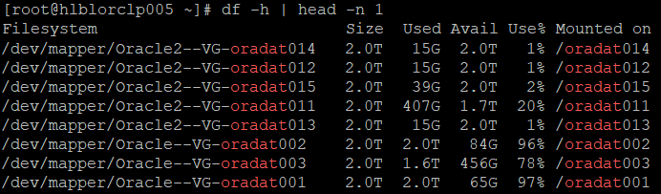

If new file system needs to be created, then please follow below steps:
- Add 3 news disks from VMware side with size of 700 GB for each disk. And while adding make sure, you will use only controlled 1,2 and 3. (Don’t/Never use controller 0, which is used only for OS disk. We have snapshot enabled for all disks from this controller so we can’t keep the DB File System here, we use “RMAN” for DB backup)
- Steps to add disks from VMware:
- Login to VCenter: https://hlbavctrp101.corp.standard.com/ with _ts id.
- Search the VM and click on Edit Settings:
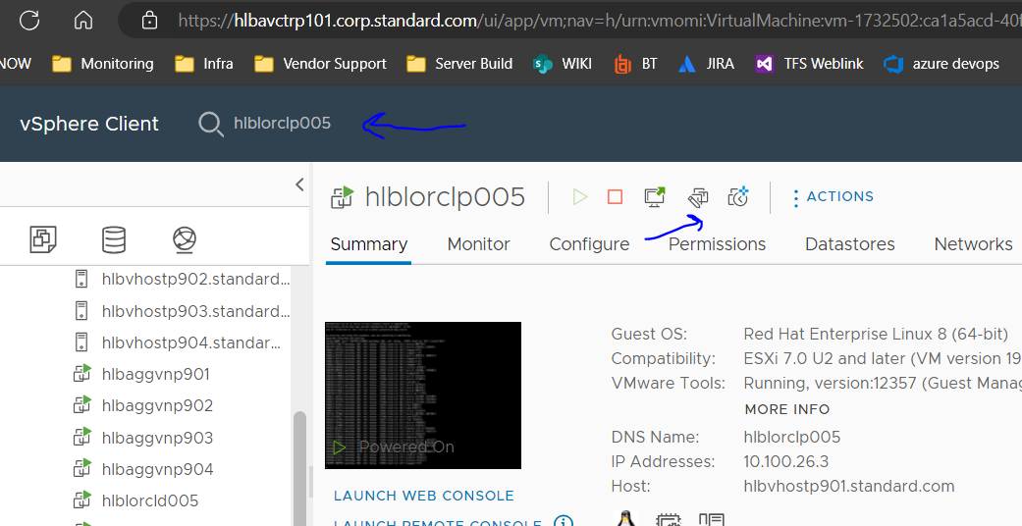

- Click on Add New Device and select Hard Disk:
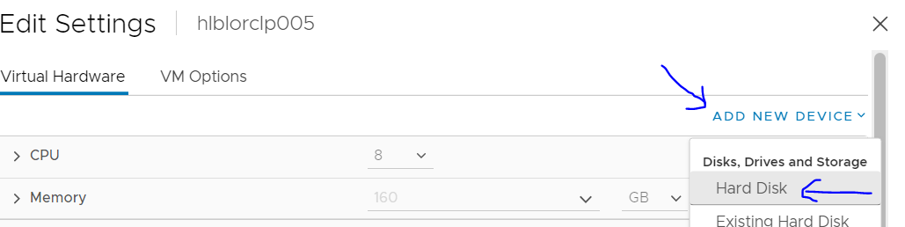
- It will add the new hard disk, provide the size as 700 GB, select THIN PROVISION as disk provision policy and SCSI controller as 1, 2 and 3 for disk1, 2 and 3 respectively.
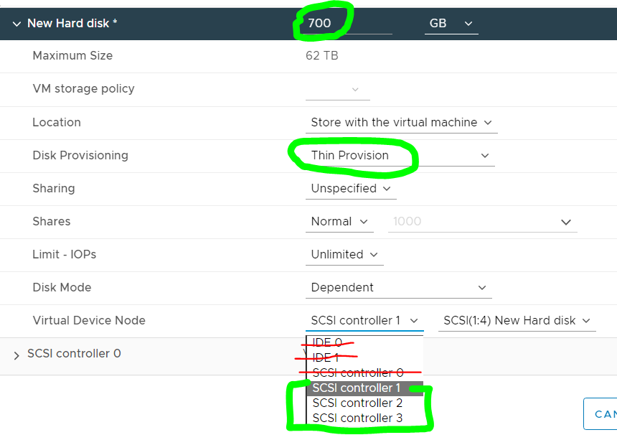
- You need to add 2 more disks as you have added in step iv.

- Once disks are added, then you need to follow below steps:
(here, I am taking an example for existing disks)
Run # lsblk command to check the newly disks added. For an example, we have created /oradat001. Please refer below captures:

# lsblk | egrep -a 1 "sdaa|sdao|sdm" (let say these 3 disks are newly added)
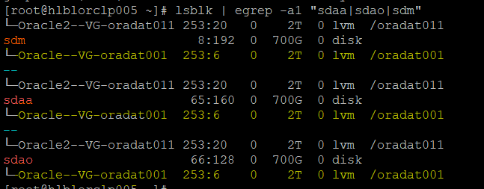
- To check the disks comes from which SCSI controller, run below command:
# lsscsi | egrep -i "sdaa|sdao|sdm"
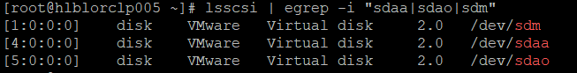

- Create the PV and extend the VG
# pvcreate <all 3 new disks, separated with white space>
# vgextend <vg_name> <3 new PVs which was created in previous command>
- Now, we can create the new LV
# lvcreate -L<size> -i <stripes> -I <stripe-size> -n <lv-name> <vg-name>
e.g # lvcreate -L2T -i 3 -I 512 -n oradat001 Oracle-VG /dev/sdm /dev/sdaa /dev/sdao
check the newly create LVM and disks attached to it:
# lvs -o +devices | grep -i <lv_name>

